SESSION 10: RDBMS (CONTD.)

Assignment 2

Table of Contents

1. Introduction .......................................................................................................................................... 3

2. Objective ............................................................................................................................................... 3

3. Prerequisites ......................................................................................................................................... 3

4. Associated Data Files ............................................................................................................................ 3

5. Problem Statement ............................................................................................................................... 3

6. Expected Output ................................................................................................................................... 3

7. Approximate Time to Complete Task ................................................................................................... 3

**1. Introduction**

This assignment will help you understand the concepts learnt in the session.

**2. Objective**

To understand and be able to manipulate SQL queries.

**3. Prerequisites**

Not applicable.

**4. Associated Data Files**

Use the Sakila schema, which can be found in following link (to be installed in your local system)

http://dev.mysql.com/doc/index-other.html("sakila database")

http://dev.mysql.com/doc/sakila/en/sakila.html(for full documentation)

**Requirements**

For each question, you are required to provide the following:

- The SQL query you used

- The answers

- Any assumptions you made

**5. Problem Statement**

4. Return the first name, last name and city of all customers who live in Canada. Order the re-sults first by the last then by the first name.

**ANS: SELECT customer.first_name,customer.last_name,city.city,country.country**

**FROM customer JOIN address ON customer.address_id = address.address_id**

**JOIN city ON address.city_id = city.city_id JOIN country ON city.country_id = country.country_id WHERE country.country='Canada' ORDER BY customer.last_name,customer.first_name**

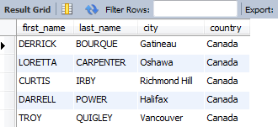

5. How many customers are from Brazil?

**ANS: SELECT country.country, COUNT(customer.customer_id) AS total_customers**

**FROM customer JOIN address ON customer.address_id = address.address_id**

**JOINcity ON address.city_id = city.city_id JOIN country ON city.country_id = country.country_id**

**WHERE country.country='Brazil';**

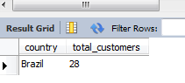

6. Return the "popular countries"? (that is, the ones with more than 20 customer). For each such country, return its name and its correspond number of customers. Order the result by the number of customers (descending).

**ANS: SELECT country.country, COUNT(customer.customer_id) AS total_customers**

**FROM customer JOIN address ON customer.address_id = address.address_id**

**JOIN city ON address.city_id = city.city_id JOIN country ON city.country_id = country.country_id**

**GROUP BY country.country HAVING COUNT(customer.customer_id)>20**

**ORDER BY total_customers DESC,country.country;**

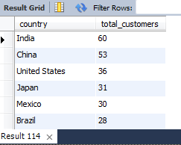

**6. Expected Output**

N/A